9-24-14

Unlearning4b in II Category Learning

Overview

This is exactly line Unlearning4 with one exception. In Unlearning4 we had the 75/25 manipulation during intervention. In Unlearning4b we want to have the fully (100%) random feedback during intervention. Here are the dual task conditions again taken from Unlearning4.

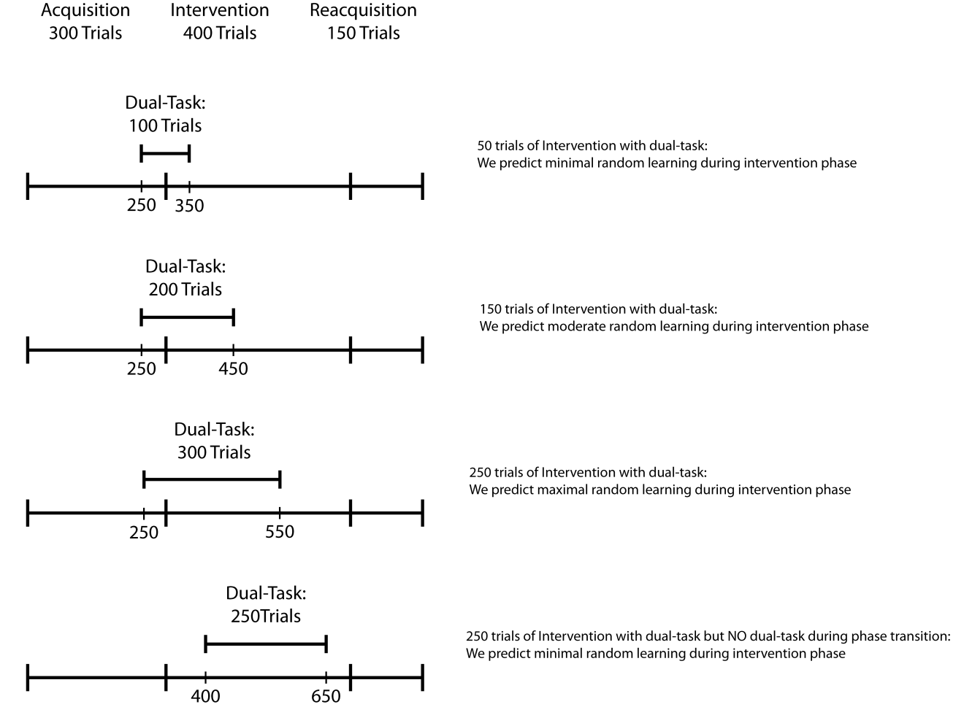

For lack of better terminology we will call these conditions 1 – 4 from top to bottom of the figure above.

We also need a control condition that has NO dual task trials.

As far as file names lets go with un4b1x.dat, un4b2x.dat, un4b3x.dat and un4b4x.dat where un4b denotes unlearning experiment 4b, the 1 – 4 is the condition and the x is the subject number. We will also have un4bcx.dat for the control condition.

Let’s start with 10 in each of these 5 conditions.